# ASSIGNMENT (3-09-2025)

Submitted by : Srividya Arul Raju

Roll number: 23KQ5A0206

1. To Check the Prime Number.

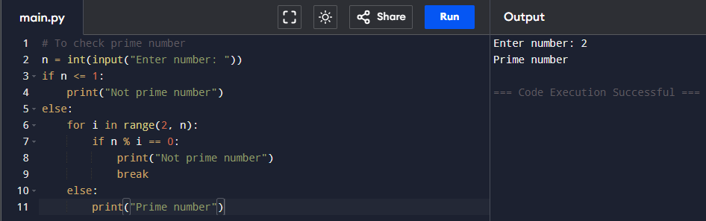

1. 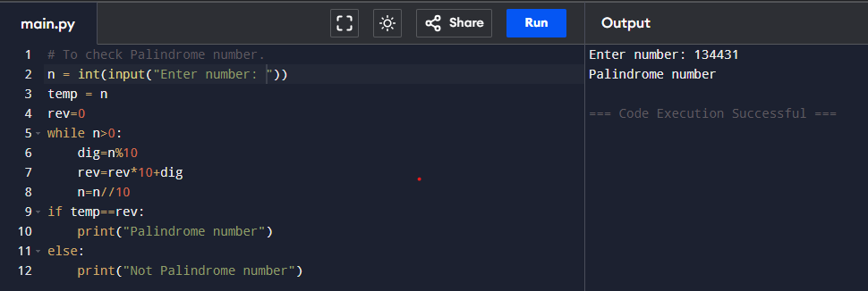To Check the Palindrome number.
2. 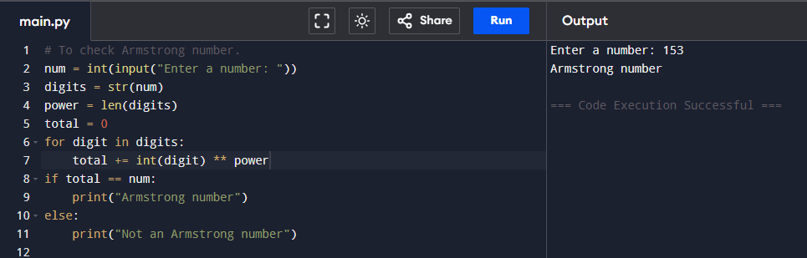To check Armstrong Number.
3. 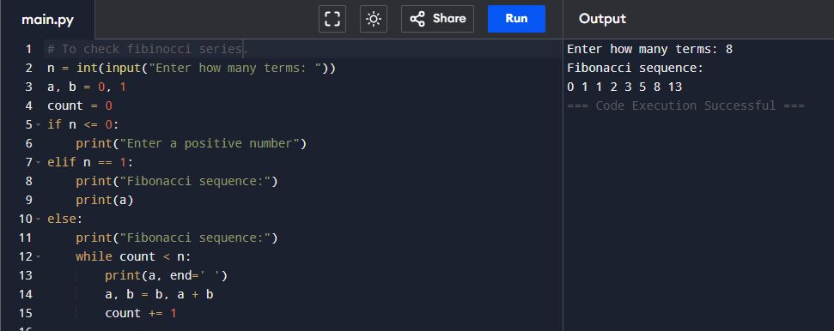To check Fibinocci Series.
4. 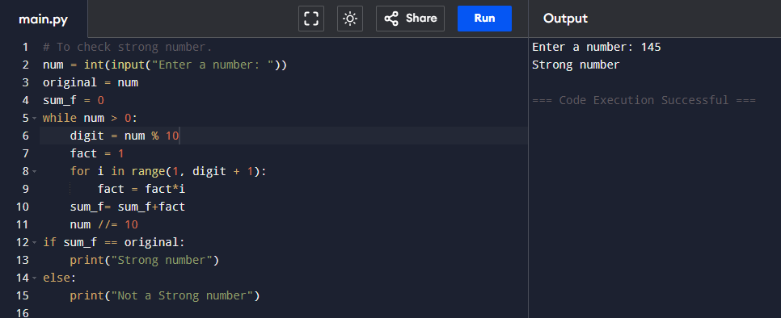To check Strong number.